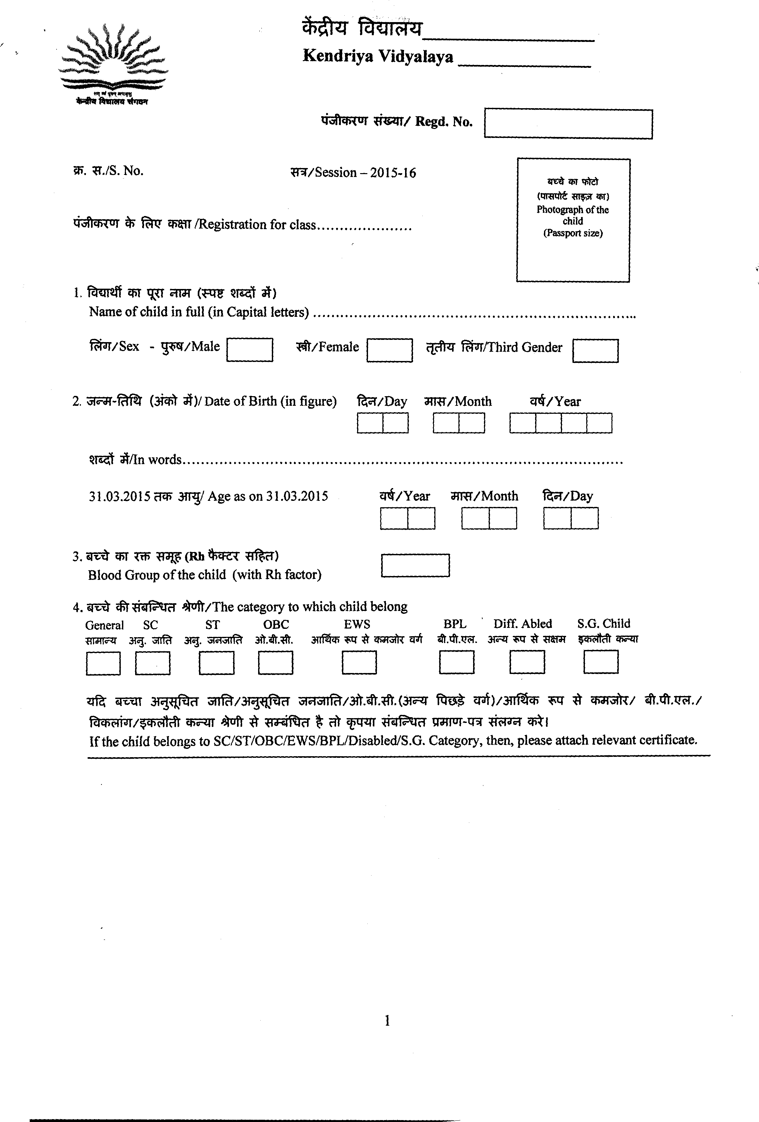

2023-24

31.03.2023
2019-20
2020-21
31.03.201
31.03.2019
31.03.2023

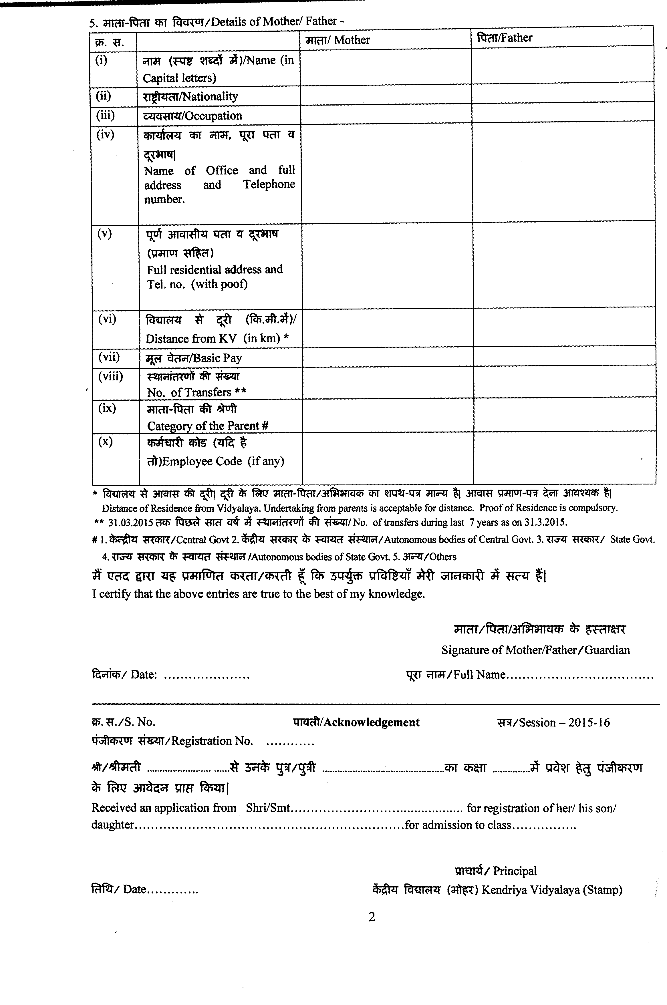

31.03.2023 31.03.2023
1.03.2019
1.03.2019
3
3 31.03.2020

2023-24

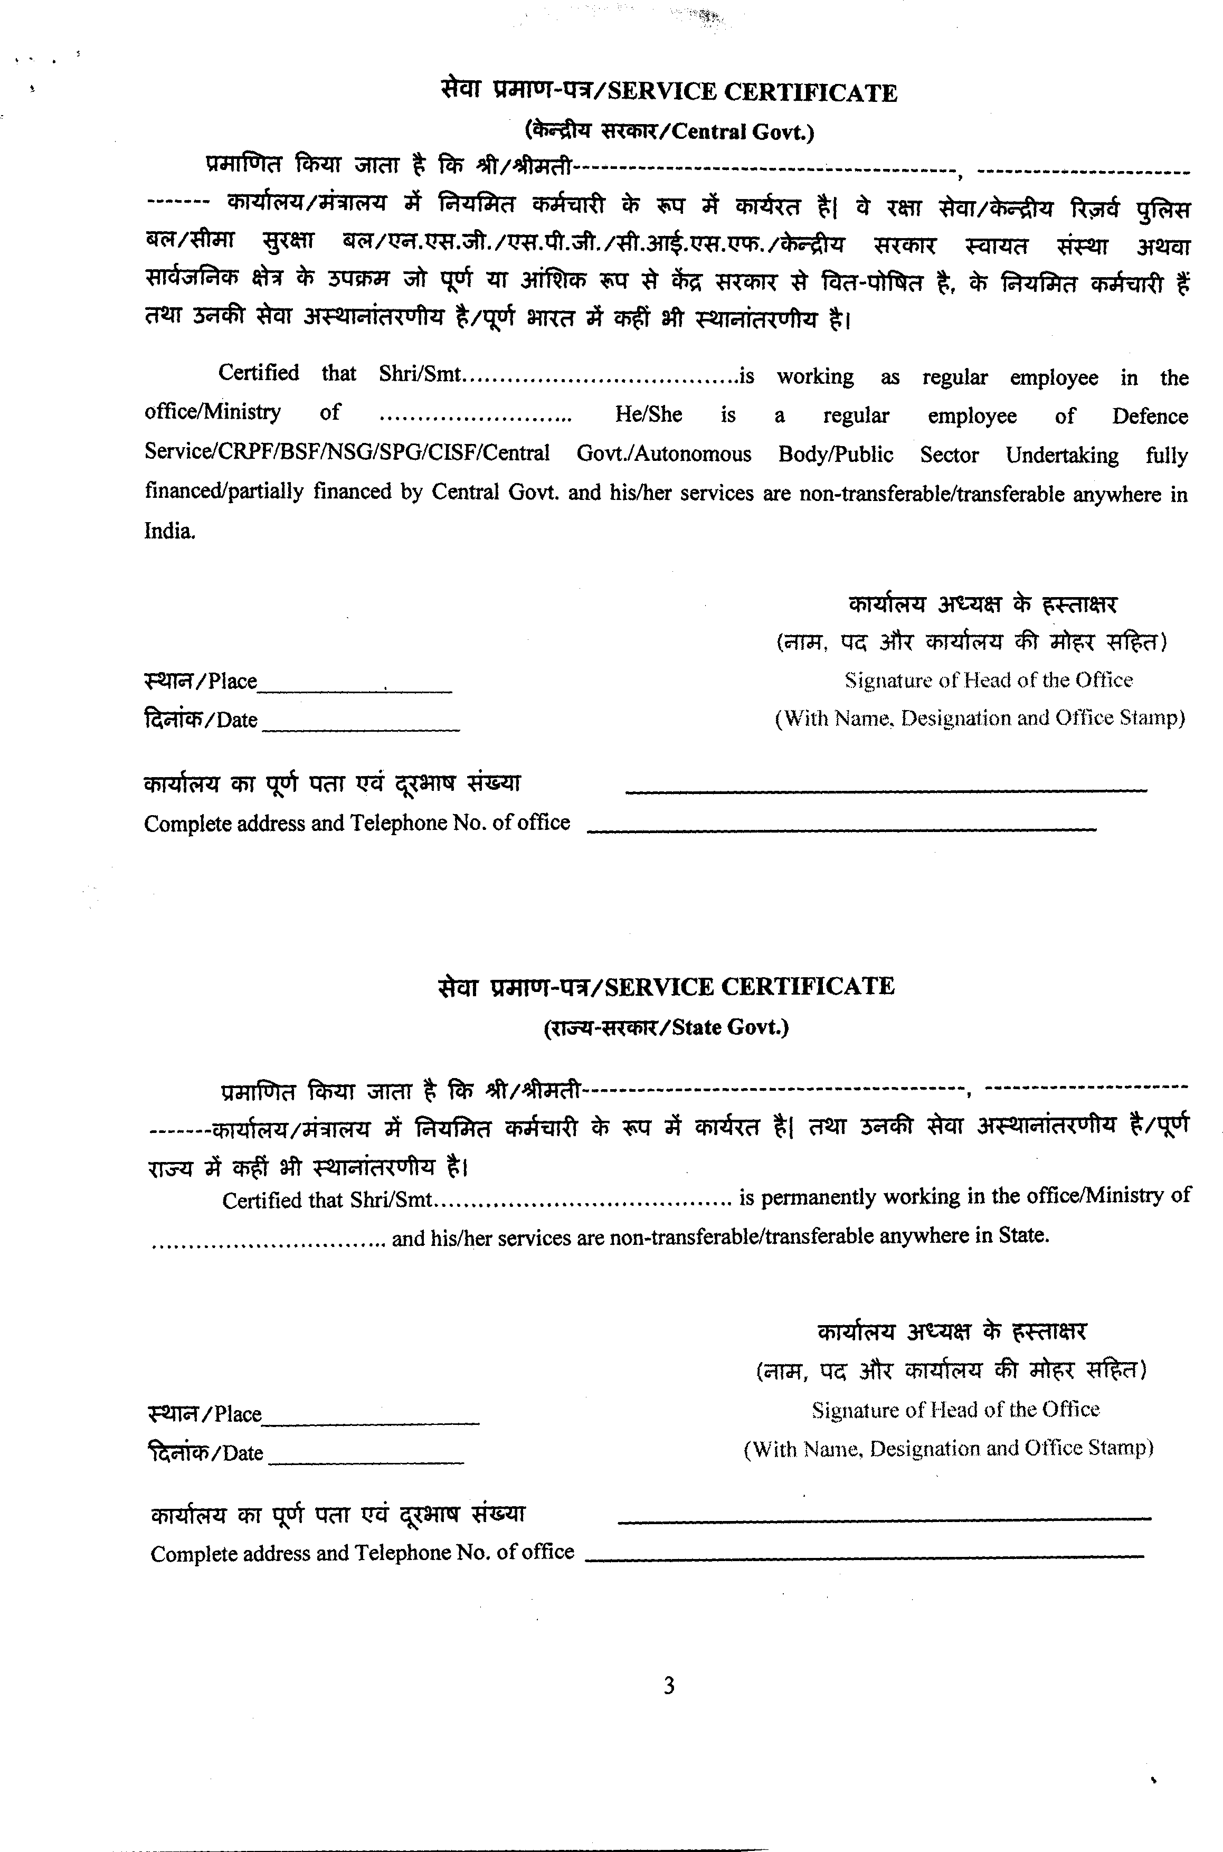

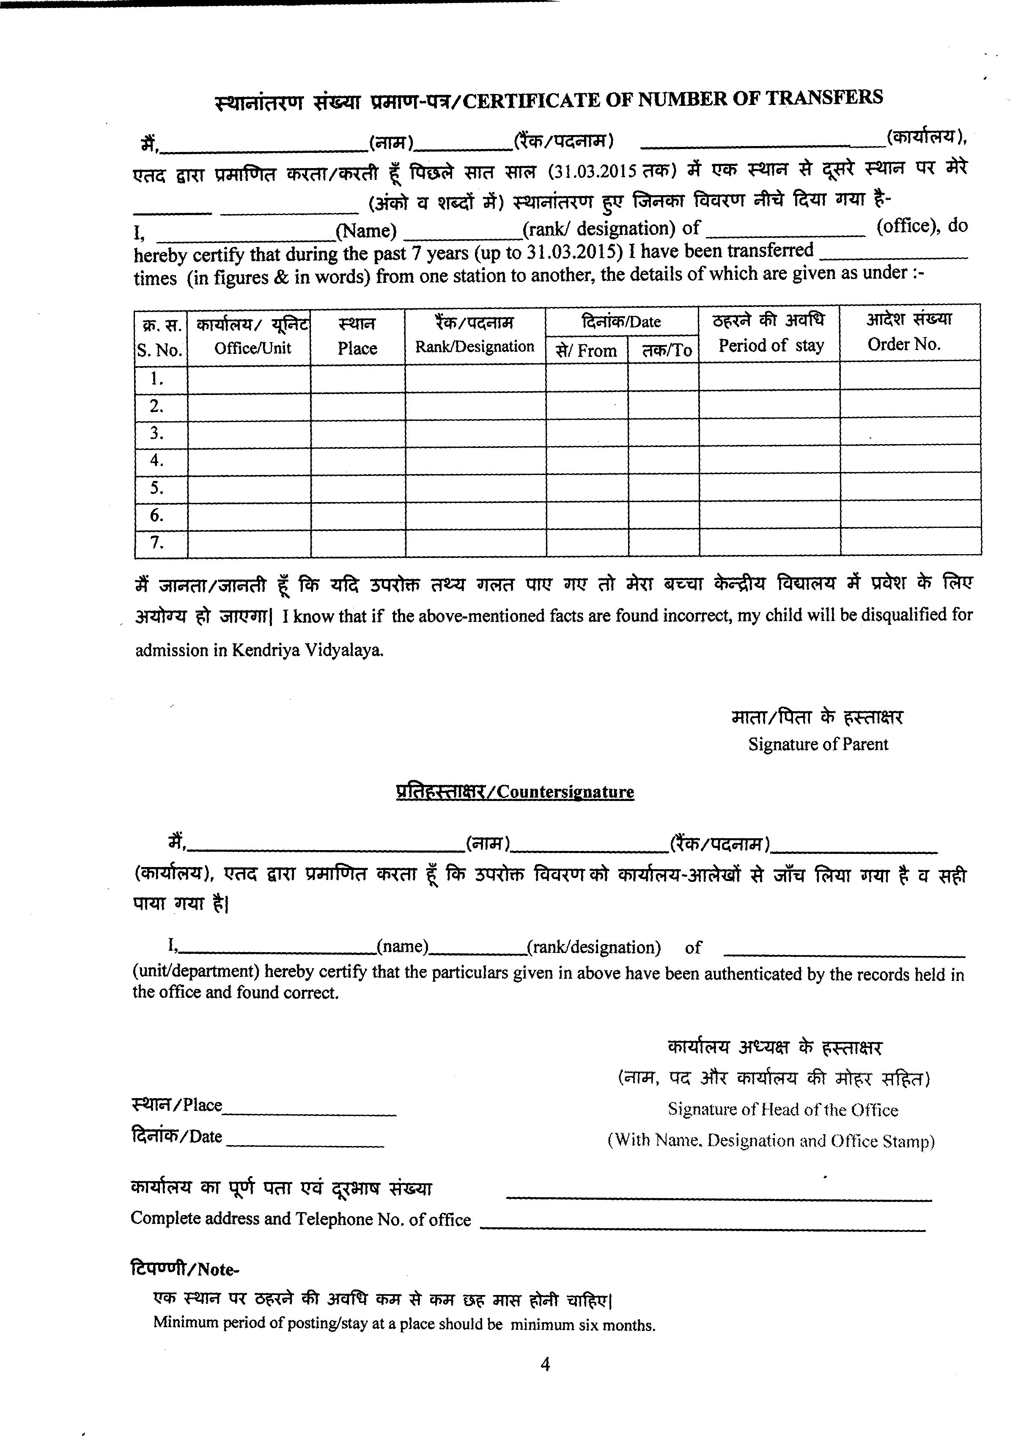
31.03.2023
31.03.2019

31.03.2023

1.03.2019
3

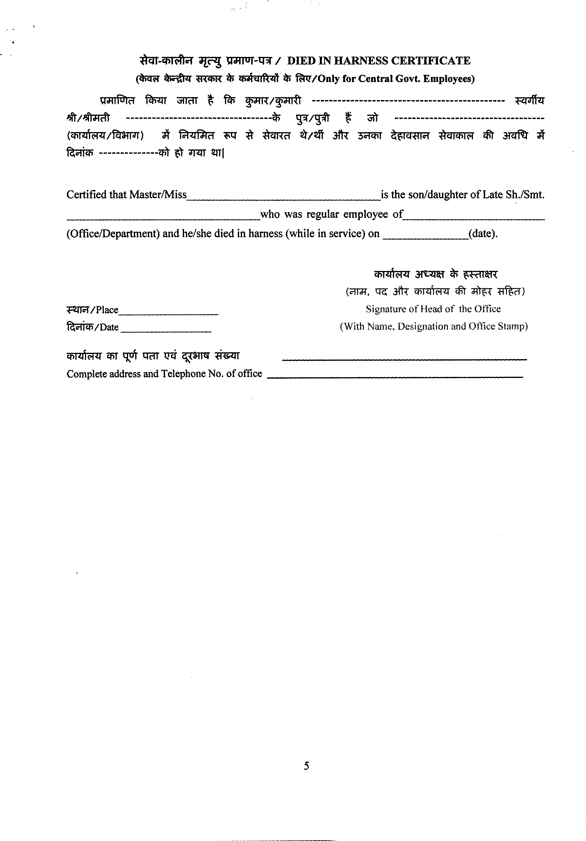

DOCUMENTS REQUIRED FOR ADMISSION IN CLASS II ONWARDS

- Original Date of birth certificate / Part-II order.[with Xerox]
- Original Service Certificate.
- Original Residence Proof. [with Xerox]
- Original Transfer Certificate.
- Original Caste certificate for SC/ ST / OBC category. [with Xerox]
- Mark sheet of previous Class.
- 07 years transfer related documents. A service certificate showing the number of transfers during the preceding 7 years duly signed and stamped by the head of office bearing the name, designation and other relevant particulars in block letters.
- Original Aadhar card of candidate[with Xerox].
- Two passport size photos.
- Blood group of candidate.
- Candidate must be present with parents for admission.

Fees details:
  - Fees will be deposited online or through challan in Union Bank of India.
  - Challan will be issued at the time of admission.

- Last date of form submission - 12.04.2023

